MINISTRY OF EDUCATION AND SCIENCE OF THE REPUBLIC OF KAZAKHSTAN

INTERNATIONAL INFORMATION TECHNOLOGY UNIVERSITY JSC

DEPARTMENT OF COMPUTER ENGINEERING AND INFORMATION SECURITY

**INDUSTRIAL PRACTICE REPORT**

**Major 5В070400 – Computer Systems and Software Engineering**

Trade ADN, Data engineer

Done by: Baizhanov N.D. 

«_11_ » __july__2020 (signature)

Head of practice: Yermukhanbetova Sh. _________________

«___ » ______2020 (signature/assignment)

Almaty 2020

International Information Technology University JSC

Department of Computer Engineering and Telecommunications

Major 5В070400 – Computer Systems and Software Engineering

Responsibilities :

* To complete and solve real cases
* To practice and do calculations
* To analyze data from tables using Python(JSON files)
* To finish the internship

CONTENT

1. INTRODUCTION
2. MAIN PART  
   2.1 Java SE programming language
   1. Code examples
   2. PL/SQL
   3. Python libraries
   4. Kotlin
3. CONCLUSION
4. REFERENCES

List of terms and abbreviations

INTRODUCTION

Trade ADN is company that developing developing in the different spheres of life including IT sphere. There are 3 departments: Data Engineering, Support Team and JQS Department.

Me, as an Data Engineer, completed tasks that were given by mentor. They were related to learning Java programming language, PL/SQL and Android Mobile application.

* 1. Java SE programming language

Java Standard Edition (Java SE) is the standard edition of Java, client applications are developed for it and this site is completely devoted to Java SE. Applications can run on their own or as web browser applets.

* 1. Code examples

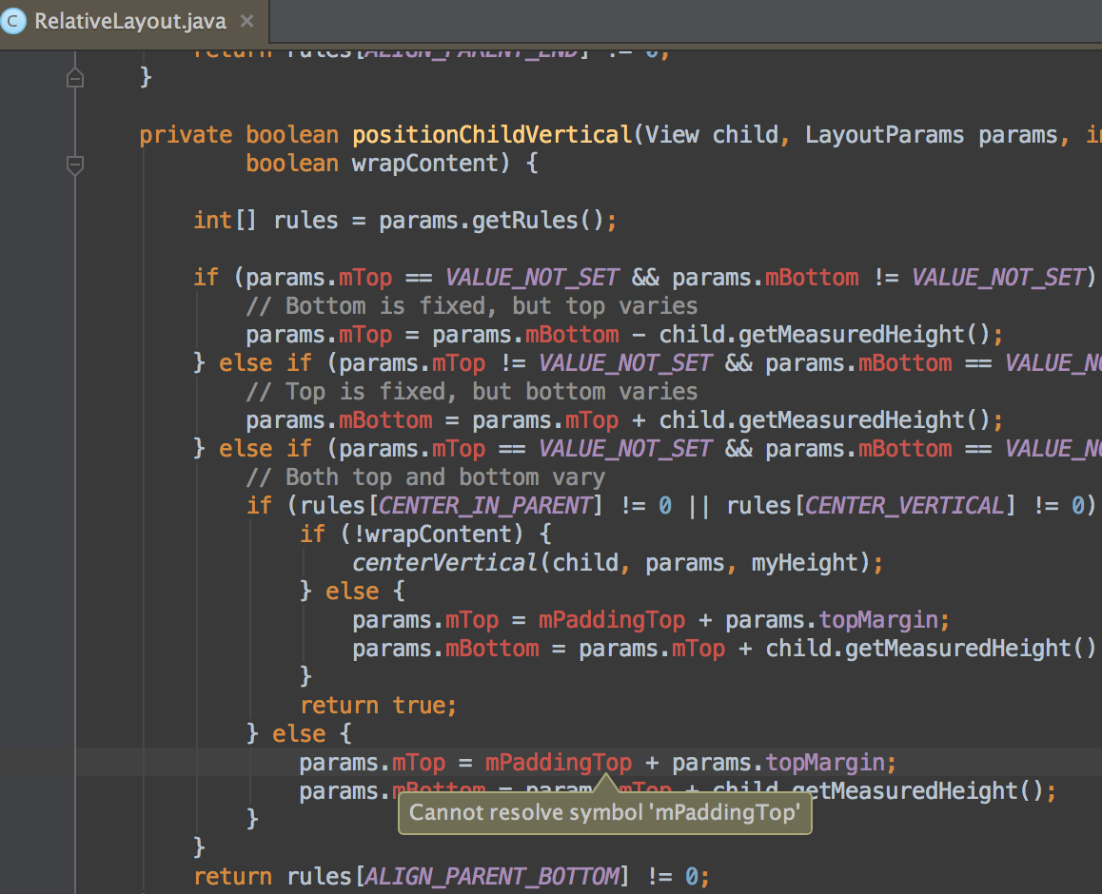

* 1. PL / SQL (Procedural Language / Structured Query Language) is a programming language, a procedural extension of the SQL language developed by Oracle Corporation. Based on the language of Ada .  
     PL / SQL is embedded in the following DBMSs: Oracle Database (from version 7), TimesTen (from version 11.2.1) and IBM DB2 (from version 9.7). PL / SQL is also used as an embedded language for Oracle Forms rapid development tools, Oracle Reports and Oracle Application Express development tools.
  2. Code examples

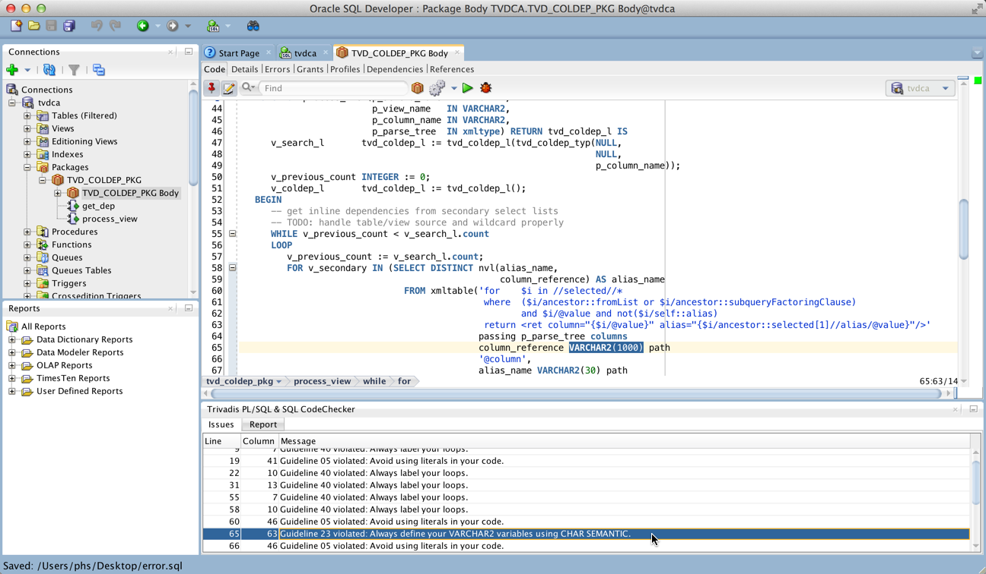

**Kotlin** (/ˈkɒtlɪn/) is a cross-platform, statically typed, general-purpose programming language with type inference. Kotlin is designed to interoperate fully with [Java](https://en.wikipedia.org/wiki/Java_(programming_language)), and the [JVM](https://en.wikipedia.org/wiki/Java_virtual_machine) version of Kotlin's standard library depends on the Java Class Library, but type inference allows its syntax to be more concise. Kotlin mainly targets the JVM, but also compiles to JavaScript (for e.g. frontend web applications using [React](https://en.wikipedia.org/wiki/React_(web_framework))) or native code (via [LLVM](https://en.wikipedia.org/wiki/LLVM)), e.g. for native [iOS](https://en.wikipedia.org/wiki/IOS) apps sharing business logic with [Android](https://en.wikipedia.org/wiki/Android_(operating_system)) apps. Language development costs are borne by [JetBrains](https://en.wikipedia.org/wiki/JetBrains), while the Kotlin Foundation protects the Kotlin trademark.

On 7 May 2019, Google announced that the Kotlin programming language is now its preferred language for [Android](https://en.wikipedia.org/wiki/Android_(operating_system)) app developers. Since the release of [Android Studio](https://en.wikipedia.org/wiki/Android_Studio) 3.0 in October 2017, Kotlin has been included as an alternative to the standard Java compiler. The Android Kotlin compiler targets Java 6 by default, but lets the programmer choose to target Java 8 up to 13, for optimization, or more features.

CONCLUSION

After finishing the Internship in Trade AND company I started to understand how to work in team work and write understandable code for team members. Also I learnt Java language program and PL/SQL, Python languages.

REFERENCES

1. <https://oracle.com/> Information about PL/SQL
2. [https:// kotlinlang.org/](https://numpy.org/) Information about Kotlin
3. <https://java.com/> Information about Java SE